IMPLEMENTING FARMER’S E-AGRICULTURE PLATFORM INTERGRATED WITH GPS TECHNOLOGY IN E- AGRICULTURE

CHISAKA FRED MUSUMBA
KAKAMEGA COUNTY ASSEMBLY
&
CHARLES MAINA

PRESENTED TO MISS. AMINA MUKONZO OF THE DEPARTMENT OF INFORMATION COMMUNICATION & TECHNOLOGY
COUNTY ASSEMBLY OF KAKAMEGA

12th JULY, 2023

DECLARATION
This report is our original work and has not been presented for approval in any other university.
Signature……………………………………………….Date…………………………………......
Chisaka Fred Musumba

Signature……………………………………………….Date…………………………………......
Charles Maina

This report has been submitted for approval by our lecturer
Signature……………………………………………….Date…………………………………......
Miss. Amina Mukonzo

DEDICATION
This work is dedicated to our families which have relentlessly taught us to rise up and shine despite the many challenges we may have faced together. They have always encouraged us to never give up saying that the roots might be bitter but at the end we will enjoy the fruits of hard work.

ACKNOWLEDGEMENT
We highly appreciate our supervisor Mr. Peter Mutoka and his counterpart Miss. Amina Mukonzo for believing in us and providing necessary requirements. We thank them for the encouragement and useful critique of this project. We cannot forget friends for their endless support in the project. God bless you all.

Contents
DECLARATION 1
DEDICATION 2
ACKNOWLEDGEMENT 3
Table of Figures 5
ABBREVIATIONS 6
ABSTRACT 7
CHAPTER 1 8
1.0 INTRODUCTION 8
1.1 Background 8
1.2 Problem Statement 9
1.3 Main Objective 9
1.4 Objectives 9
1.5 Scope 10
1.6 Significance 10
CHAPTER 2 11
2.0 Literature Review 11
2.1 Introduction 11
2.2 The literature review 11
2.3 Summary 14
CHAPTER 3 15
3.0 Methodology 15
3.1 Introduction. 15
3.2 Project Methodology. 15
3.3 Summary 18
CHAPTER 4 19
4.0 RESULTS AND EXPERIMENTATION 19
4.1 Introduction. 19
4.2 Discussion. 19
CHAPTER FIVE 25
5.0 SUMMARY AND CONCLUSION 25
5.1 Introduction 25
5.2 Summary 25
5.3 Conclusion. 26
References 27
Appendices 29
Glossary 30
Index 33

Table of Figures
Figure 1: The tools used for the software Development. 16
Figure 2: Pages and their contents. 17
Figure 3: How we developed the system. 18
20
Figure 4: The navigation bar and slider section. 20
Figure 5: About us and our services section 20
Figure 6: Regions links. 21
Figure 7: Region Crops 22
Figure 8: Register form. 24

ABBREVIATIONS

GPS: Global Positioning System
EA: Electronic Agriculture
GDP: Gross Domestic Product
ICT: Information and Communication Technology
GIS: Geographical Information System
KARI: Kenya Agricultural Research Institute
SDK: Software Development Kit
HTML: Hypertext Markup Language
CSS: Cascading Stylesheets

ABSTRACT
The aim of this research was to determine the current status of GPS application in E-agriculture research in Kenya.
Our project is to bring new achievements both for farmers and companies. Farmers will get educated on how to use their regions’ specializations to maximize on their yields. Students in agricultural fields will be able to acquire educational information on regions’ soils, climate, pests, diseases in those regions, crops and help find more answers to some unanswered farming questions.
GPS will help companies enjoy some new features like easy tracking and location. This means that their transportation and location work would have been made easier.
According to Strobel J., 2014. Drake journal of agricultural law. Summer 2014 Volume 19, No.2 Agriculture Precision Farming, Educating farmers will help them own agricultural information improving agriculture. We are helping farmers gain more knowledge and own agriculture using the E-agriculture platform.

CHAPTER 1

1.0 INTRODUCTION

1.1 Background
Agriculture is fundamental for Kenya‘s economic development. The Kenyan agricultural industry needs to be healthy for it to participate in job creation, social welfare, food security, the country‘s gross domestic product (GDP), and the value of raw materials as Gold Blatt, 2010 states. The growing awareness in E-agriculture research in recent years has shown E-agriculture to be an emerging trend in information and communication technology use of agriculture in the rural areas as Patrikakis & Maumbe, 2012(South Africa) describes. E-agriculture research in general is focused on efforts to unlock the potential of ICTs in agriculture with various stakeholders, such as private, public, as well as international governmental and non-governmental organizations in various parts of the world willing contribute to the sustainability and productivity of agricultural industries. Researchers should give investigation of specific contributions of e-agriculture research a first priority to enhance agriculture and specific problems in ICT implementation and use. Understanding early e-agriculture research in Kenya will assist both current and future generations with creating new and better ways to develop the agricultural sector when using this modern GPS technology
Advancements in technology have led to availability of tracking and positioning systems which can trace position of people and moving machines. The production and development of such hardware and software services have been experiencing an increase in demand in the information technology market for the last few years. Farmers who are able to access online services have increased in the last few years. To ensure we meet the market’s requirements of the use of such services, we explored the possibility of integrating Global Positioning System for locating farm machineries especially those used for transportation to locate the farms and merged it with a farmer’s platform where they can easily access important information on farming. This venture is beneficial since companies will easily access their clients’ positions making access to their coordinates very easy; the farmers will be able to acquire useful information on their region’s climate, favorable cash crops, fertilizer and pesticides to use.

1.2 Problem Statement
Despite the growing interest in e-agriculture research in Kenya, academic studies have not sufficiently and in-depth investigated the current e-agriculture research trends in the Kenyan context. It is unclear how primary e-agriculture research in Kenya will aid both current and future generations to create new and better ways to transform agricultural development using this modern technology.
In 2014, two scholars, Mahesh Kadibagil PG Scholar, Department of ISE, BMSCE, Bangalore, India and Dr. H S Guruprasad Professor and Head, Department of CSE, BMSCE, Bangalore, India came up with position tracking and detection system which uses GPS and Web Technology in order to enhance the positioning experience by alerting the user of the position a person is in. We will improve it by ensuring that real time information about the information is stored and can be easily retrieved instead of just being an alert. Different organizations have integrated tools like Office Automation, Wireless Technology, GPS and automated systems to facilitate E-Agriculture. Even though the tools are in work, they are not 100% reliable. This is because of inaccuracy of acquired data in some locations and lack of awareness and common platforms for farmers.
Instead of using the two scholars’ idea for tracking and positioning a person’s location, our system tracks a transportation machinery and locate position of a farm on a map. We reduced the gap in E-Agriculture by developing a platform where farmers will acquire more information on agriculture and Global Positioning System to increase organizations’ data accuracy.

1.3 Main Objective
Improving productivity in Electronic Agriculture by implementing Global Positioning System and a better farmer’s E-Agriculture platform.

1.4 Objectives
- Analyze the existing farmers E-Agriculture platforms and how the of Global Positioning System is currently being used in agriculture.
- Find out the challenges being faced by agricultural companies due to lack of Global Positioning Systems implementation.
- Develop an improved farmers’ platform and Global Positioning System to be applied in E-Agriculture.
- Test, implement and validate the new enhanced farmers’ platform and Global Positioning System.
- Validate the system and receive real-time feedback from users.

1.5 Scope
We discovered that there are many E-Agriculture platforms for farmers but are not 100% reliable. Famers still need more information concerning their region’s soils, climate, recommended pesticides and crops. We also discovered that many companies that deal with transportation of goods find it difficult to locate their clients and machines. Our GPS implementation help such companies easily locate their clients and transportation machines. The new E-Agriculture will help more information about the mentioned areas and many more.

1.6 Significance
The aim of this research was to determine the current status of GPS application in E-agriculture research in Kenya.
Our project is to bring new achievements both for farmers and companies. Farmers will get educated on how to use their regions’ specializations to maximize on their yields. Students in agricultural fields will be able to acquire educational information on regions’ soils, climate, pests, diseases in those regions, crops and help find more answers to some unanswered farming questions.
GPS will help companies enjoy some new features like easy tracking and location. This means that their transportation and location work would have been made easier.

CHAPTER 2

2.0 Literature Review

2.1 Introduction
This chapter focus on comparison between our proposed project and the existing ones to review the existing features and techniques to help us come up with improvements not showcased by the existing applications.
There is lack of understanding of how E-agriculture research in Kenya can influence agriculture to improve the wealth level of many Kenyan farmers. A literature review was conducted to understand different studies related to ICT adoption and use in agricultural companies to know how Global Positioning System, agricultural information systems, use of geographic information, the use of satellite enhancing agriculture and providing broader information on agriculture can be well used to improve E-Agriculture as objected by this study.

2.2 The literature review
According to Baumeister (2013), a systematic literature review is a strategy which uses explicit and organized procedures to assess, determine, identify and gather and analyze pertinent research papers that are relevant to the study. Furthermore, Okoli (2015) points out that a systematic literature review is described as scientific and the correct secondary study currently preferred by researchers to conduct primary and secondary studies as it uses a predetermined search method

2.2.1. The Existing E-agriculture Platform.
a). Argus.
Argus is a good E-agriculture platform. Its main agenda is teaching African farmers more about fertilizers by use of manual conferences held each year across the African fertilizer chain. This means that farmers get more information on fertilizers only leaving them with no option but to look for additional information elsewhere. A farmer can apply fertilizer as directed but can it be productive when the crop was planted in a good climatic region or region with good soil? It is a no.
b). E-agriculture.
This is a platform for many as they receive news related to ICTs for agriculture that is events taking place like workshops and meetings. It enables farmers go for agricultural meetings and workshops. This is a good platform but it only focuses on meetings and workshops and agribusiness. Our platform will offer farmers more knowledge on farming and events like trainings and workshops and also enabling companies keep track on farms and their transportation machineries.
c).KARI.
It is a Kenyan based organization. Their platform is mainly for research purposes. They contact research like pest control and update farmers on their findings and measures to use for controlling such situations. It is a good platform but farmers need more than just research findings. That is why our platform will offer farmer more than just research.

2.2.2. Challenges
According to Ortmann (2011), lack of education in the efficient use of ICT, high cost of certain modern ICTs like GIS and GPS, poor infrastructure in rural areas and time taken to obtain information from the Internet are the major problems affecting the use and adoption of ICT in agriculture in Kenya. Furthermore, Simpson and Calitz (2014) point out that the manner and extent to which ICTs such as mobile technology and the Internet are used by the farming community is a big challenge for Kenyan agricultural sector especially when updating or implementing techniques for extension services. Many farmers do not get adequate knowledge to help them in their daily farming practices. Most of them depend on advices from friends who may not be as efficient as the information offered by platforms like our E-Farm. Platform.
. In a study conducted by Zewge and Dittrich (2015), a systematic literature review was conducted to understand ICT-based studies for agriculture in developing countries. The results of this study indicate that there is still a long way to go despite gaining the attention of ICT in agriculture with several contributions. The study furthermore indicates that there are limited knowledge areas in user interface designs, including methods and theory explaining the design of information systems for rural community areas. The lack of education and knowledge challenge can be avoided or reduced by ensuring farmers get adequate and reliable information that will help them up their agricultural practices and maximize on productivity.

2.2.3. Development of Our Improved System.
Our Global Positioning System is made simpler so that anyone is able to acquire and use to maximize on data acquisition instead of having to spend money on expensive systems that are offering the less services. Our system has two parts, the admin part and the other users’ part. In the other users’ section, farmers know more about farming. A farmer can choose a region where he/she comes from and know more about the regions’ climate, soils, crops that do well in the region and pesticides to apply in case a need arise. The admin part is for the company. Companies will be able to keep in touch with their farmers by storing their information and their farm details. They will also be able to trace locations of their machineries and goods on transit.
In the last few years, several studies have been conducted in the E-Agriculture field using different methodologies, not many studies have considered reviewing E-Agriculture research and understanding how E-Agriculture research can contribute to agricultural development by applying and adapting new improved Global Positioning Systems. There is a need to understand the current state of E-Agriculture research conducted by a number of researchers. This captured our attention to improve E-Agriculture by implementing Global Positioning System for tracking moving agricultural machineries and farm location and merge the system with a better farmers’ platform to give many farmers across the globe an access to unlimited agricultural knowledge.
According to Ortmann (2000), modern ICTs such as global positioning systems (GPSs) can assist with determining individual property rights to cropland for small-scale farmers. Our system has a database that will store one’s details, the size of land owned and location so that incase a case that needs determining one’s property rights arise, one can refer to our database.
In 2011, Guohuo MinMark Schneider wrote about Systems and methods of wireless position tracking which explained that position tracking involves identifying an entity’s location in a predefined environment by comparing the signal strength at each receiver position. He did not clearly state that this idea could be used in agriculture for locating farms and tracking transportation machineries which we would implement using GPS.
In 2014, two scholars, Mahesh Kadibagil PG Scholar, Department of ISE, BMSCE, Bangalore, India and Dr. H S Guruprasad Professor and Head, Department of CSE, BMSCE, Bangalore, India came up with position tracking and detection system which uses GPS and Web Technology in order to enhance the positioning experience by alerting the user of the position a person is in. We will improve it by ensuring that real time information about the information is stored and can be easily retrieved instead of just being an alert.
In 2015, WSIS documented on E-Agriculture’s effectiveness across the globe. An issue that we identified is that many farmers are not yet informed. Coming up with a better farmer’s platform will highly educate farmers and encourage them to adapt E-Agriculture.

2.3 Summary
In this chapter, we discussed problems affecting the use and adoption of Global Positioning System ICTs and farmers in E-Agriculture and the need for improved implementation of GPS in agriculture. Furthermore, the systematic literature review was discussed. This includes reasons for using a systematic literature review and a systematic literature review on E-Agriculture and GPS implementation.
Based on the literature review on previous existing systems and platforms, it’s clearly known that there is still more to be done for E-Agriculture to be widely used across the globe giving us the opportunity to focus on coming up with a platform to give farmers knowledge and the implementation of GPS to be used by companies for easy positioning and tracking.

CHAPTER 3

3.0 Methodology

3.1 Introduction.
This chapter focuses on our step-to-step methods of how we intend to achieve our system’s objectives
GPS implementation has a major positive impact on improving E-Agriculture’s productivity. Data storage on crops, farms, climates, pests, fertilizers and farm machineries is on demand in these technological days.
According to Tembo (2008), several famers are not interested in traditional ways of keeping data anymore because the use of ICT is becoming increasingly popular (ICT includes the GPS). However, the use and adoption of ICT is sensitive to variables such as educating the producers, age and technological level, insertion in the production chain, size, location, and income level of the operation (Rodrigues, 2012).

3.2 Project Methodology.
We used the incremental model life-cycle to come up with our system whereby we designed, implemented and tested our system incrementally until it was finished. This will help ease the load of introducing completely our new system at once and also make early corrections in case they arise.

3.2.1 Planning.
We made consultations with support personnel to direct us on the right steps to take. We used Brackets, Visual Studio and MySQL in XAMPP for our system’s development. They will help us in integrating the different programming languages to come up with our system. Languages are JavaScript, PHP, HTML and Cascading Stylesheets.

3.2.2 Requirements
We need a GPS software in the machine to track, a database (in this case, we used MySQL in XAMPP), Brackets and Visual Studio SDK. These helped us develop our system with greater performance capabilities.

Task | Tool used for the task | SDK
Database creation | MySQL | XAMPP
Connection to the database | PHP Language | Visual Studio/Brackets
Dynamic and interactivity of the page | JavaScript | Visual Studio
General design and makeup | HTML and CSS | Visual Studio/Brackets

Figure 1: The tools used for the software Development.

3.2.3 Analysis & Design.
GPS tracker is implanted on all transportation machineries. Those trackers are then accessed by the server at the endpoint via the satellite. Once a person needs to know where a tractor or any other transportation machine is, a request is made emitting a signal to the satellite. The satellite then locates the device and forwards the signal to it. The receiving device then sends back the signal to the satellite which sends back the signal to the server. At the server, the signal is translated to a map giving the location of the device.
For farm location, the location of the farm is displayed on a map and the coordinates of the farm are obtained giving us where the farm is. One can view where the farm is and a vehicle can easily be used to transport a product from the farm as long as its location and coordinates are known.
Our design is based on the fact that the existing E-Agriculture platforms are not 100% reliable and farmers still need more information. Our platform will inform them concerning their region’s soils, climate, recommended pesticides and crops and how they can easily manage their farms to increase on their productivity. Many companies that deal with transportation of goods find it difficult to locate their clients and machines. We are designing a GPS software that will help such companies easily locate their clients and transportation machines. The new E-Agriculture platform on design is to help farmers gain more information about the mentioned areas and many more.
We designed the system in the simplest manner possible to ensure ease of navigation by the user.
Below is a sample of information on pages and what the pages consist.

Figure 2: Pages and their contents.
Our project is aimed at bringing new achievements both for farmers and companies. Farmers will get educated on how to use their regions’ specializations to maximize on their yields. Students in agricultural fields will be able to acquire educational information on regions’ soils, climate, pests, diseases in those regions, crops and help find more answers to some unanswered farming questions.
GPS will help companies enjoy some new features like easy tracking and location. This means that their transportation and location work would have been made easier.

3.2.4 Development.
After writing our codes, we integrated them to come up with a complete system. We availed it for testing and made it ready to be used by the customers for production.
First, we developed the website using HTML, CSS, PHP and JavaScript. We then created database to store machinery information farm details and farmers’ details. Lastly PHP code was written to connect the database dependent pages to the database as shown in the flow below:

Figure 3: How we developed the system.
Time to time maintenance will be done to solve any post-production issue that may arise.

3.3 Summary
We did our research and came up with proposal of improving productivity in E-Agriculture and helping companies trace and locate their machineries and clients. By doing so, the gap of making E-Agriculture 100% reliable is closing.

CHAPTER 4

4.0 RESULTS AND EXPERIMENTATION

4.1 Introduction.
Agriculture plays a vital role in every human life and economy from thousands of years ago. Still, the importance of agriculture is a lot deeper than anything in this entire world.
In this revolutionary world still, many countries face issues with old farming techniques like seeding, fertilizing, irrigation, lack of machinery, etc. To rectify agricultural problems, we have come up with an E-Agriculture platform with GPS and geofencing to map and locate farmers on a map.

4.2 Discussion.

4.2.1. Home
The home page of the website has several links in the header section, some in the body and the footer. The links helps one navigate on the navigation bar and open his/her own page of concern. Links are Home, Services, Fields, Operations and Register. The links are linked to the homepage itself, services provided by the organization, fields recorded in the database where various crops are transported from, operations that the company carries out using the machineries as per the client request and the registration form that allows farmers input their details that help the company keep in touch with them. The image slider gives the page a dynamic appearance making it user friendly to interact with.
The Discover button helps user explore more about the services provided by the company like climatic information, soil information, pesticides and crops likely to do well in the region a user wants to practice agriculture.
The Learn more button allows a potential user to get more information in relation to the field of interest making him/her know a lot about us.

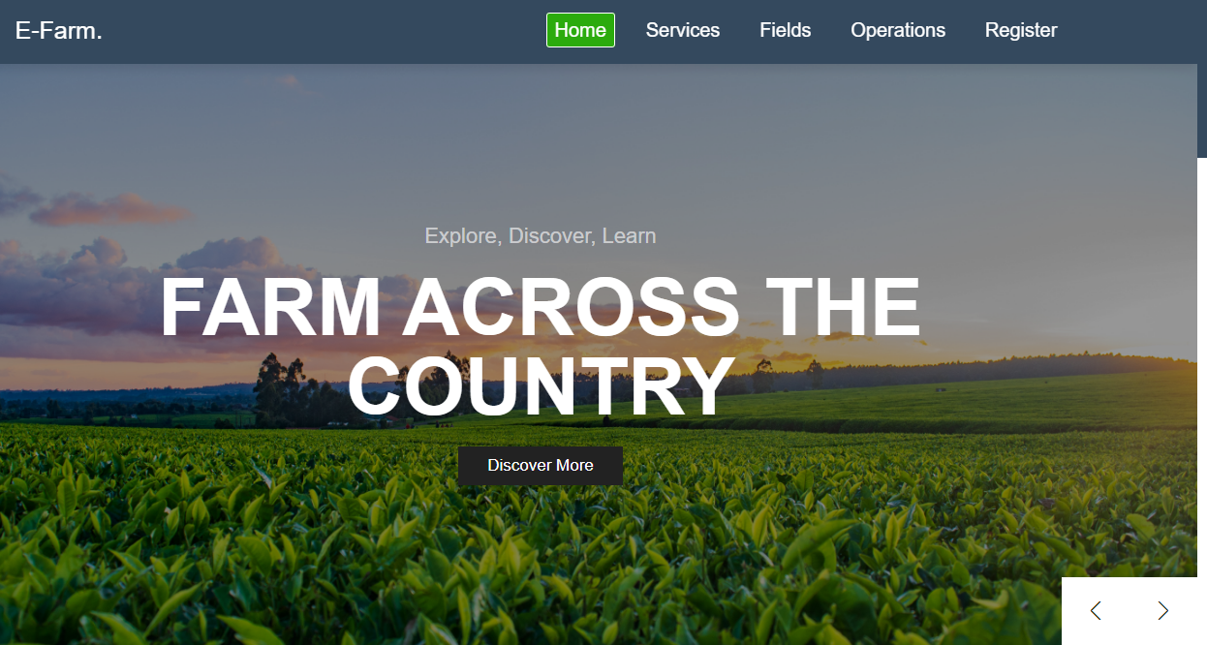

Figure 4: The navigation bar and slider section.

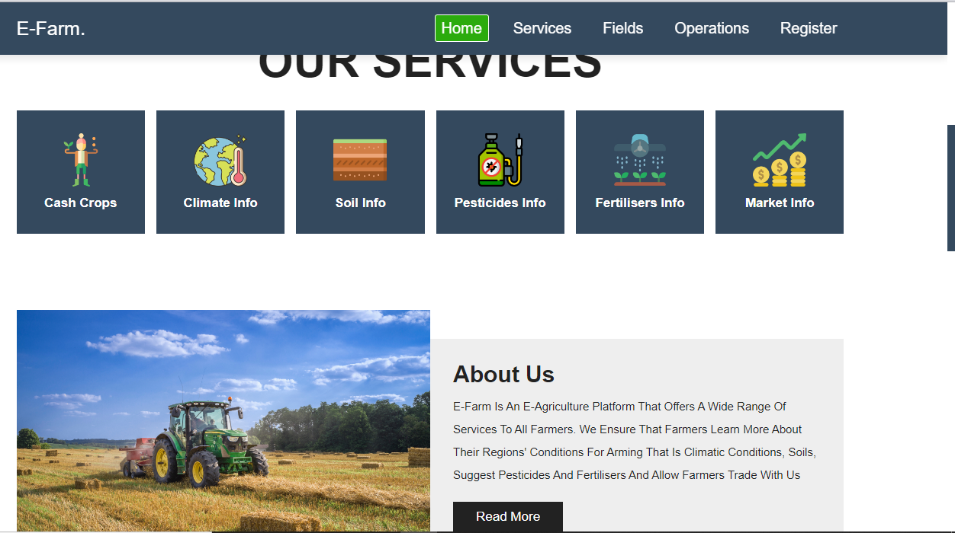

Figure 5: About us and our services section
The marketing section enables user to register and contact us to transport his/her product to the market or manufacturer.
The footer section has links to various pages whose links are also on the navigation bar, links to various social media accounts where a farmer can keep in touch with any updates made and links to help him/her learn more.
Since html is limited to webpage design capabilities, we used CSS to make our pages more organized, attractive and user friendly for a user to interact with.
HTML is good but to enjoy its reliable output, cascading stylesheets are used for decorating the pages by ensuring all elements are well positioned, colors of the various elements are well used and that the theme of the page goes in line with the purpose that the webpage is meant to fulfil. We used CSS to well decorate our webpage to ensure that users find it friendly and attractive to use. We used it to ensure a farmer or any user can easily retrieve data of importance a lot offer.

4.2.2 Services
The services page allows a user acquire knowledge on the climate of the region he/she comes from, soils, crops that do well in those areas and pesticides information so that one can get maximum yields from practicing agriculture.
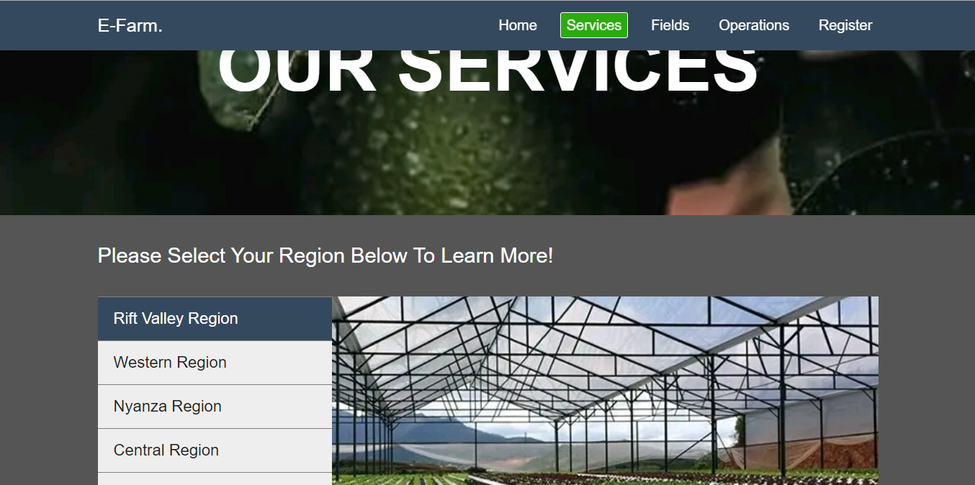
First, the farmer chooses his/her region from the ones provided. This redirects the farmer to the region’s page where information concerning the region is provided.

Figure 6: Regions links.

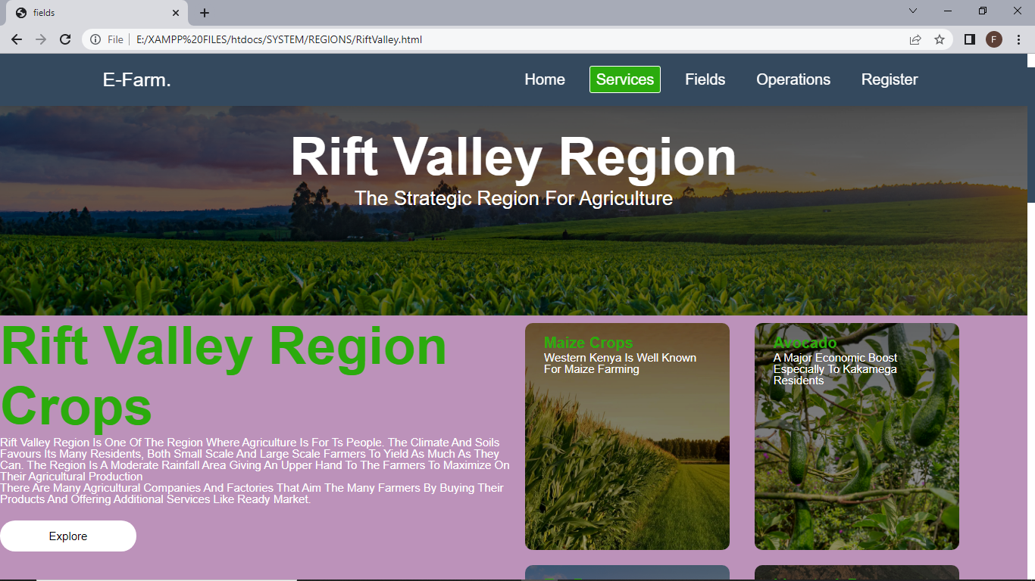
Figure 7: Region Crops

4.2.3. Fields
The fields section contains the farms located at various places across the country. When the farmer registers, details of the farmer are recorded in the database that is farmer’s name, location of the farm, farm size and the crop grown in that farm. The information is then stored in the database. The admin then establishes the Geofence of the farm and retrieves the farms’ coordinates and the location which are displayed on the map. This enables the company to keep locations of their farmers and calculate the output that can be required for such a farm like transportation cost and required machineries in relation to the crop being grown in that farm. The admin can edit farmer’s details if requested to do so or if the farmer edits on the other end.
Farm location is important for it enables company locate where most of their farmers or customers are located to keep in touch with them or open a branch near them to help them even more.
The shown names like Field 1, are links to the details of that field. When you click on the link, another page containing the fields’ details is displayed as shown in the figure below.

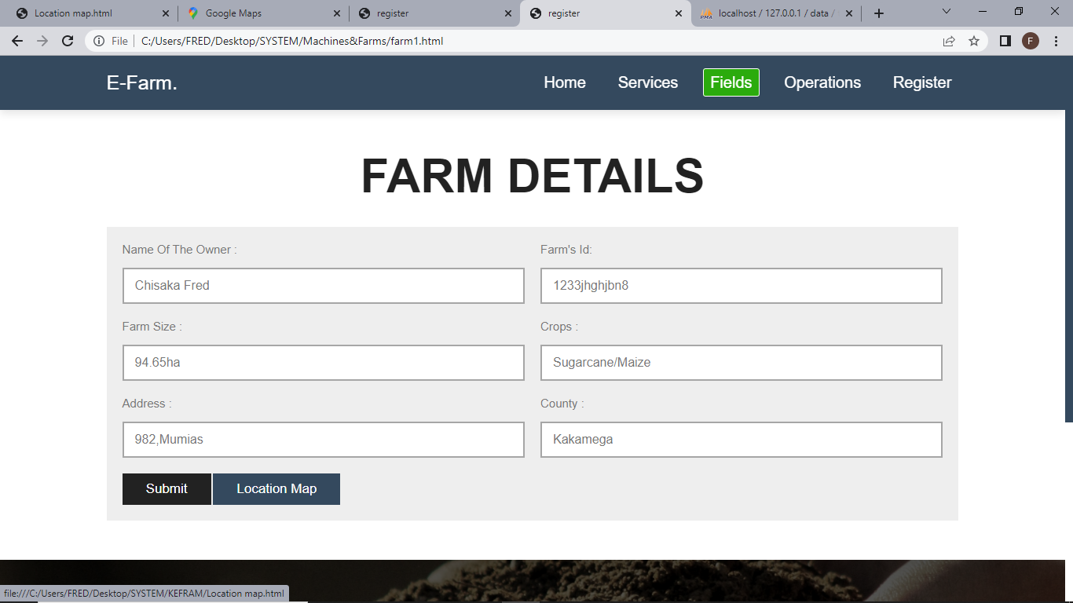
The details of the farm are displayed that is the name of the owner, id given to the farm by the company, farm size, crop grown in the farm, address of its location and the county where located. The admin can edit and submit the details which are then submitted in the database.
The button labelled Location map once clicked displays the geofenced piece of land on a map. One can obtain the longitude and the latitude of the location of the map and store them in the database shown in the figure below.
One can edit the Geofence, delete it or add another Geofence and name the crop grown in that Geofence.
We used HTML and CSS to design the page. We used PHP to connect the webpages with forms to the database to ensure that the page interacts with the database where data can be retrieved from the database or added to it. For interaction purpose and to make the page dynamic, we used JavaScript.

4.2.4 Operations.
In the operations page, the details stored are of the company’s transportation machineries. A farmer may have a farm product that he/ she wants to be transported from the farm to the market or to a manufacturer for processing or he/she can request for goods like seeds, fertilizers, pesticides and more from us. The farmer can contact us for the contact details are given. When a farmer makes such a request, it means that the company has to release one of its machineries to the place. The fields section thus contains the details of the machineries used for transportation and delivery. The details include the Driver’s name, contact, vehicle type, its id, number plate, product to transport from which point to its destination, departure time and arrival time.
Once the vehicle has set off, the admin can track the live location of the vehicle and determine if the driver is on the right root or determine the time taken to move between the destinations in relation to the speed. The location is displayed on a map using GPS thus enabling live tracking.
Below is a sample screenshot of the tracking made between two points.

4.2.5 Register.
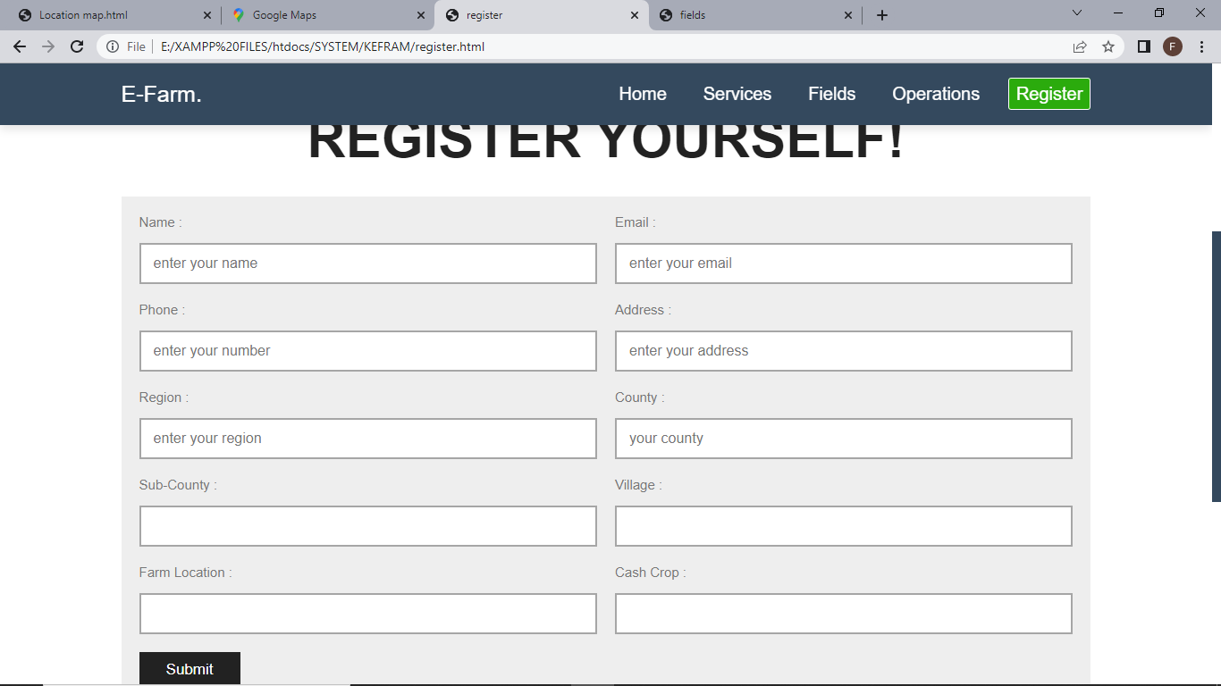
The registration form is to help company establish a connection with the farmer by knowing more like name, farm size, location and more. This helps the company in determining statistics like crops mostly grown in certain areas and keeping farmer’s record to easily reach him or her. It also makes it easier to contact a farmer to get feedback.

Figure 8: Register form.
The records are stored in the database. We used HTML, CSS and PHP to design this page. PHP was for connecting the form to the database so that the entered data can be stored in the database.

CHAPTER FIVE

5.0 SUMMARY AND CONCLUSION

5.1 Introduction
This chapter provides the summary and conclusions pertaining the research study findings. This shortens the gap that makes E-agriculture not 100% reliable.

5.2 Summary
We analyzed the existing farmers E-Agriculture platforms and how the of Global Positioning System is currently being used in agriculture. There are E-agriculture platforms that provide some information to farmers but the information is either unreliable, inaccurate or incomplete leaving farmers with some yet unanswered agricultural problems.
Our research found out the challenges being faced by agricultural companies due to lack of Global Positioning Systems implementation. In Kenya, many companies have not yet embraced the advantages of having a good GPS system that can make their work of locating machineries and farms on a map easier. Companies have the fear of failure of such system or the system obtaining inaccurate data Many farmers are still not able to acquire the necessary information concerning what to plant, when, where and how due to the changing weathers and climatic conditions.
The system we developed is an improved farmers’ platform and Global Positioning System to be applied. The platform provides farmers with more information concerning agriculture which keeps them aware of their area’s climate, soil, crops and pesticides. We make real-time updates to the platform keeping farmers updated on agricultural changes. Our system allow for location of transportation machineries and farms on a map making it easier for companies to transport products from one location to another and to easily access their clients’ farms and buy their products.
We carried out testing, implementation and validation of the new enhanced farmers’ platform and Global Positioning System enabling us to experiment the functionality of the system so that users can get a glimpse of what the system can do.
System validation was carried out successfully and the system’s functionality is meant to be advantageous to many farmers and companies across the country.

5.3 Conclusion.
E-agriculture plays a major role in improving productivity in agriculture in our country. Implementing the GPS system and integrating it with the farmer’s E-agriculture platform will have a positive impact in this country’s farming resulting to an improved economy for many farmers and companies across the country.
Companies and other concerned agricultural organizations will be able to easily locate farm machineries in case of transportation or farming reasons and also locate farms on a map and easily locate them. Farmers will be able to access any information concerning agriculture that is climate, soils, crops, pesticides and more to improve on their agricultural practices. Let’s all embrace E-agriculture.

References
- Schrijver R., Woensel L V, Kurrer C., and Tarlton J. Scientific Foresight project 'Precision Agriculture and the future of farming in Europe, 2016. Scientific Foresight Unit (STOA), Directorate-General for Parliamentary Research Services, European Union, Brussels
- Shamshiri R.R., Balasundram S.K., Weltzien C., 2019. Use Cases of Digital Agriculture. Global Forum for innovations in Agriculture, Abu Dhabi, UAE
- Shepherd M., Turner J. A., Small B., 2018. Wheeler D. Priorities for science to overcome hurdles thwarting the full promise of the ‘digital agriculture’ revolution. Journal of the Science of Food and Agriculture DOI 10.1002/jsfa.9346
- Strobel J., 2014. Drake journal of agricultural law. Summer 2014 Volume 19, No.2 Agriculture Precision Farming: Who Owns the Property of Information? Is It The Farmer, The Company Who Helps Consults The Farmer on How to Use The Information Best, or The Mechanical Company Who Built The Technology Itself?
- Ullah A., Ahmad J., Muhammad K., Lee M.Y., Kang B., Soo O.B., Baik S. W., 2017. A Survey on Precision Agriculture: Technologies and Challenges. The 3rd International Conference on Next Generation Computing (ICNGC2017b) Kaohsiung, Taiwan.
- Yang C., Sui R., Lee W.S., 2016 Precision Agriculture in Large-Scale Mechanized Farming Ch. 6. In: (Zhang Q. ed.), Precision Agriculture Technology for Crop Farming. Taylor and Francis Publ., Boca Raton, FL.
- Rajkumar M. Chauhan of Oriental Scientific Publishing Co, India. 2015 Vol. 8 No.3, Advantages and Challenges in E-Agriculture.
- Gelian, S. Maohua, W. Xiao, Y. Rui, Y. Binyun, Z. 2012. On precision agriculture knowledge presentation with ontology AASRI Conference on Modeling, Identification and Control 3: 732ñ738.
- Puwadol Oak Dusadeerungsikul, Avital Bechar, in Agricultural Internet of Things and Decision Support for Precision Smart Farming, 2020.
- China Gov. Available at http://www.gov.cn/zhengce/content/2016/01/29/content_5037340.html
- China Net. 2014. Available at China.com.cn http://news.china.com.cn/2014/09/29/content_33646038.htm
- Feng Wen-jun. 2013. Application of intelligent IC card system in electromechanical well irrigation in rural areas. Hunan Agricultural Machinery, 1: 103-104.
- Hebei News. 2010. Available at http://hebei.hebnews.cn/2010-09/28/content_788491.htm 2010
- JWB. 2014. Available at http://news.jwb.com.cn/art/2014/11/20/art_179_5076967.html E-agriculture in Action 106
- Meng Ge & Shen Zhen. 2012. Present situation and countermeasure research of the collection of irrigation water fees. Economic Research Guide, 24: 213-214
- Renming. 2014. People’s Daily online. Available at http://politics.people.com.cn/n/2014/0507/c1001- 24984953.html
- Sannong. 2015. Available at http://www.farmer.com.cn/ywzt/wcg/jx/201504/t20150421_1027330.htm
- The State Council of the People’s Republic of China. Available at http://www.gov.cn/2015-04/14/ content_2846156.htm
- Wang Tong et al. 2010. Deep groundwater in North China Plain has been over-exploited for over 70%. Hebei Geology, 3: 26-26.
- Xinhua. 2013. Xinhua. Available at http://news.xinhuanet.com/fortune/2013-09/19/c_117428735.htm
- Xinhua. 2014. Available at Xinhua http://news.xinhuanet.com/fortune/2014-08/27/c_1112248453.htm
- Xinjiang News. 2014. Available at http://cj.xjkunlun.cn/xncjs/xncjs/2014/4238491.htm

Appendices
The project took 21 days to its completion. We used different sources to refer, identify liabilities and to get as more information as possible to put as many requirements as possible into consideration and develop the best solution. We intend to use maps to ensure that we develop a good GPS system for improved agricultural productivity in our country Kenya.

Glossary
Abstract: (1) A prospectus of what a presenter intends to present at a conference. (2) A summary of a technical paper.
Pseudocode: A generic name for any code syntax that resembles a programming language but is not intended to be compiled and executed.
Technical reports: Documents that are prepared for supervisors, subordinates, peers, customers, clients, and various government agencies.
Advancements: An improvement relating to a particular activity or area of knowledge.
Button: Clickable element that take actions
Coordinates: Unique identifier of a precise geographical location on the earth.
Critique: A detailed analysis and assessment of something.
CSS: A computer language for laying out and structuring webpages.
Database: An organized collection of structured data typically stored electronically in a computer system.
Detection: Action or process of identifying the presence of something concealed.
E-Agriculture: Refers to agricultural services and information delivered or enhanced through the internet and related technologies.
Embrace: An act of accepting something willingly or enthusiastically.
Footer: Section having information related to author, data containing copyright information or some links related to the data.
Geofence: A virtual perimeter for a real-world geographic area.
GDP: Total monetary/market value of all goods and services produced within a country’s border within a specific period of time.
GPS: A system that uses signal from satellites to find out position of an object.
Hardware: Computer’s tangible components for its functionality like RAM.
Header: Represents introductory content, typically a group of introductory or navigational aids.
HTML: Standard markup language for documents designed to be displayed in a web browser.
In-depth: Comprehensively and thoroughly.
Infrastructure: Basic physical and organizational structures and facilities like roads needed for the operation of a society or enterprise.
Integration: Process of combining two or more things into one.
Latitude: A coordinate that specifies the north-south position of a point on earth’s surface.
Literature Review: A piece of academic writing demonstrating knowledge and understanding of the academic literature on a specific topic placed in context.
Longitude: Imaginary lines that bisect the globe through the North and South Poles.
Machinery: An established system for doing something.
Methodology: A system of methods used in a particular area of study or activity.
Pertinent: Relevant or applicable to a particular matter.
Predefined: Defined, set or arranged before something is done.
Predetermined: Decided or arranged at an earlier time.
Satellite: Object send to space to collect information or to be part of a communications system.
Software: Set of instructions or programs used to operate computers and execute specific tasks.
Technology: Application of scientific knowledge to the practical aims of human life or to the change and manipulation of human environment.
Tracker: Script on website or a device designed to retrieve data during tracking.
Tracking: Maintenance of a constant difference in frequency between two or more connected circuits or components.
Trends: A change or development towards something new or different.
User Interface: Means by which the user and a computer system interact, in particular the use of input devices and software.
Venture: Activity or plan of action that involves risks and uncertainty.
Workshop: Meeting where people engage in intensive discussion and activity on a particular subject.

Index

Page number followed by an f indicates figure page, with a t indicates table page
Abbreviations, 6
Abstract, 7
Aim of research, 10
Analysis, 16-17
Background information, 8
Challenges, 12
Company, 13
Conclusion, 30
Design, 16-17
Design Model, 15
Developing improved system background, 13
Developing our system, 17-18
Development process, 17,18f
Discussion, 19
Effectiveness of E-agriculture, 14
Existing E-agriculture platforms, 11
Fields, 24-26, 25f-26f
GDP, 8
Geofencing, 19
GPS, 9
Homepage, 19-22
Implementation, 16
Improving productivity, 30
Literature review strategy, 11
Methodology, 15
Objectives, 9-10
Operations, 26-27,27f
Page contents, 17,17f
Planning, 15
Problem statement, 9
Referencing 31-32
Registration on platform, 27-28,28f
Results and Experimentation, 19
Requirements, 15
Scope, 10
Services, 22-24,22f-24f
Significance, 10
Summary, 14, 18, 29-30
Tools for software development, 16,16t
Wireless Technology, 9

